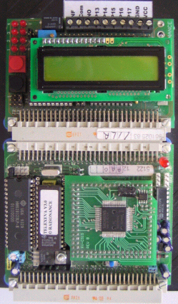

Environment
maps
Wave Propagation models

SimNetwork layer

SimAgent layer
VirtualAgent 1
Agent_1 Behavior
Agent_1 Battery Model
VirtualAgent i
Agent_i Behavior
Agent_i Battery Model
…
EmbeddedAgent i+1
EmbeddedAgent n
…

